**Question G**plot for posteriors vs 10 Gibbs sweeps

plot for posteriors vs 50 Gibbs sweeps  
  
plot of Posteriors for 40 Topics – explain changes if more topics

** Perplexity as a Function of Number of Topics  
  
** Perplexity changes with Number of Gibbs sweeps

plots for changes in Alpha (Alpha = 0.1 instead of 10)

**** Show top I words for each mixture component

** Show list of words (top 5 at least) and how it changes with number of Gibbs sweeps(?) or number of topics (?) – what does it tell you?

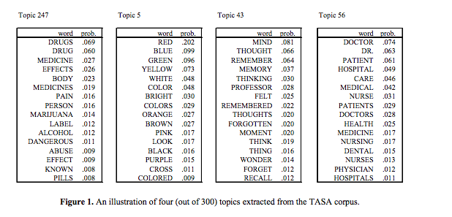

**Question I**- topic posterior with 10 Gibbs sweeps + perplexity  
  
- topic posteriors (For Document 2) for 50 Gibbs Sweeps

- Perplexity vs Number of Topics (50 Gibbs iterations)